Press release
Initiative for a sustainable future
Koenig & Bauer is now an official member of the initiative HolyGrail 2.0 - "Digital Watermarks for Smart Packaging Recycling in the EU"

- Focus on sustainable development of packaging
- Digital technology for efficient and high-quality recycling management
- Trial run successfully completed
Würzburg, xx.06.2021
For Koenig & Bauer, sustainable corporate development is a key issue for the future. As a further piece in the puzzle, the company was confirmed as a member of the Holy Grail 2.0 project in June 2021. The aim is to speed up the development of an efficient circular management system.
Under the auspices of the European brand association AIM (Association des Industries de Marque), more than 120 companies and organisations from across the packaging value chain are pooling their expertise to achieve an ambitious goal: to see if digital technology can contribute to better sorting and higher quality recycling for packaging in the EU to develop a truly efficient recycling economy.
Packaging materials are recyclable materials that should be kept in the loop. The aim of this pioneering project is to mark packaging using digital watermarks, thus simplifying machine sorting of waste for recycling and recovering high-quality recyclate. For plastics, this is even a must, because the European Union has stipulated that by 2030 only plastic packaging that can be reused or recycled may be brought onto the market.
Digital watermarks in the EU
From the previous research, digital watermarks have emerged as the most promising technology and received majority support from stakeholders. Digital watermarks are unobtrusive, stamp-sized codes printed on the surface of packaging. They can contain a wide range of identifiers, such as information on manufacturers, stock keeping units (SKUs), processed plastics and the composition of multi-layer items, food and non-food products.
The new technology passed the trial run on a test sortation line flawlessly. Now the branded goods industry is committed to implementing the next phase as a value chain initiative called "Holy Grail 2.0". This includes the commissioning of an industrial trial facility to test the viability of the watermarking technology for the purpose of accurate sorting of packaging waste and higher quality recycling, as well as conducting a large-scale business assessment scenario.
Apart from their function as a "digital recycling passport", digital watermarks are also applicable in other areas, such as customer loyalty, supply chain visibility and retail.
With its subsidiary Coding, Koenig & Bauer has many years of expertise in the field of coding solutions in its own portfolio. As an official member of the sustainable initiative, the group is now working together to find a joint solution for smart packaging recycling.
Get more information: https://www.aim.be/priorities/digital-watermarks/

Photo 1:
Digital watermarks in stamp size on the packaging
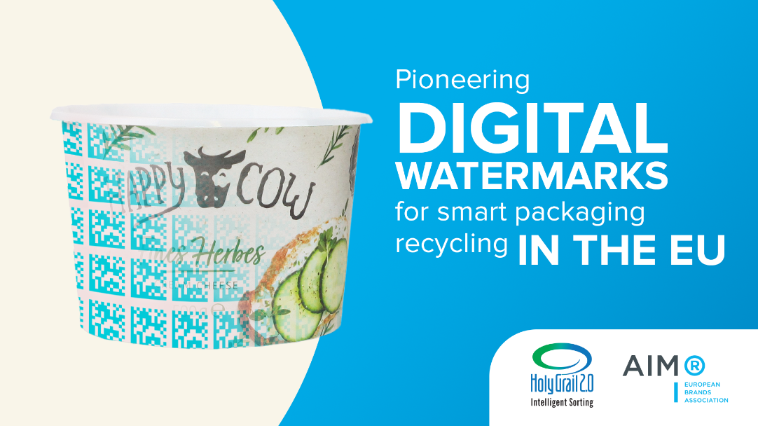

Photo 2:
Logo Holy Grail
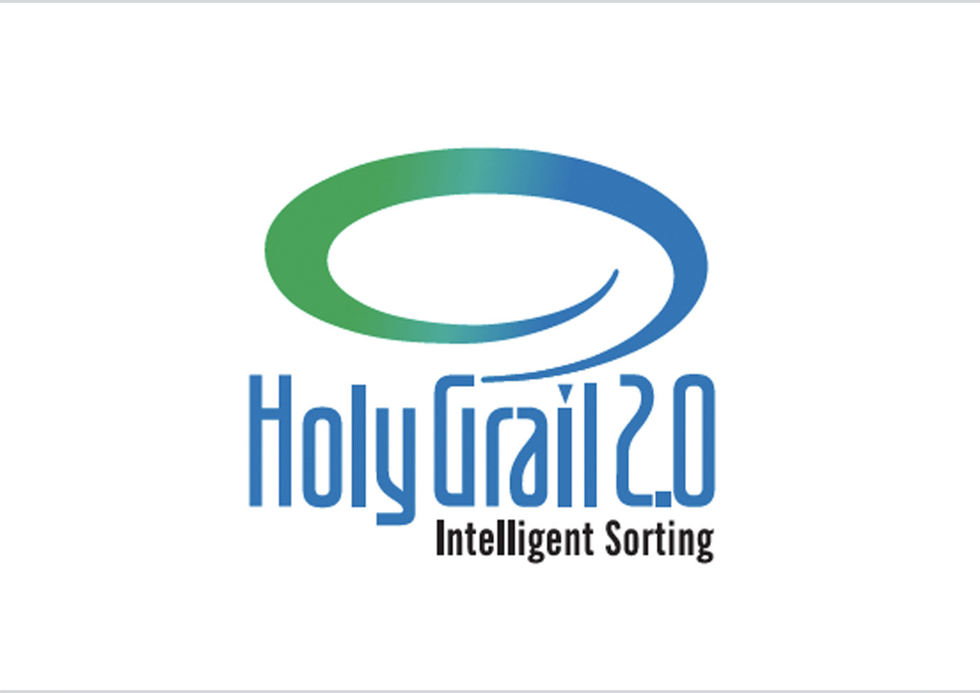

Contact person for the press
Koenig & Bauer AG
Dagmar Ringel
T +49 931 909-6756
M dagmar.ringel@koenig-bauer.com

About Koenig & Bauer
Koenig & Bauer is the world’s oldest printing press manufacturer with the widest product range in the sector. For over 200 years, the company has been supporting printers by offering innovative technology, custom-fit processes and a wide range of services. The range encompasses printing solutions for banknotes and cardboard, foil, tin and glass packaging, books, displays, labelling, decors, magazines, advertising and newspaper. With sheetfed and web offset and flexo printing, waterless offset, steel engraving, simultaneous and screen printing or digital inkjet printing, Koenig & Bauer is at home and often a leader in almost all printing processes. In 2020, the 5,593 highly qualified employees worldwide generated annual revenue of €1.029bn.
Further information can be found at www.koenig-bauer.com

